Project Report

Subscribers Galore Top Youtube Channels

1. Introduction :

1.1. Overview:
This project is about the Statistics of the Subscribers Of An Youtube Channels. Here we have collected the information about the subscribers of the top 50 Channels of Youtube. Information about the Subscribers such as their Language,Country,Thier Interest,etc… could be seen here with the use of pie chart, bar chart, maps, etc…

1.2. Purpose:
This can be used by new content creaters to be aware of what would help them achieve their goal of reaching the top Youtube Creaters. They get information on what their subscribers would love to watch and whaat further more they could do to upheld their channels content quality.

2. Problem Definition & Design Thinking :

2.1. Empathy Map:
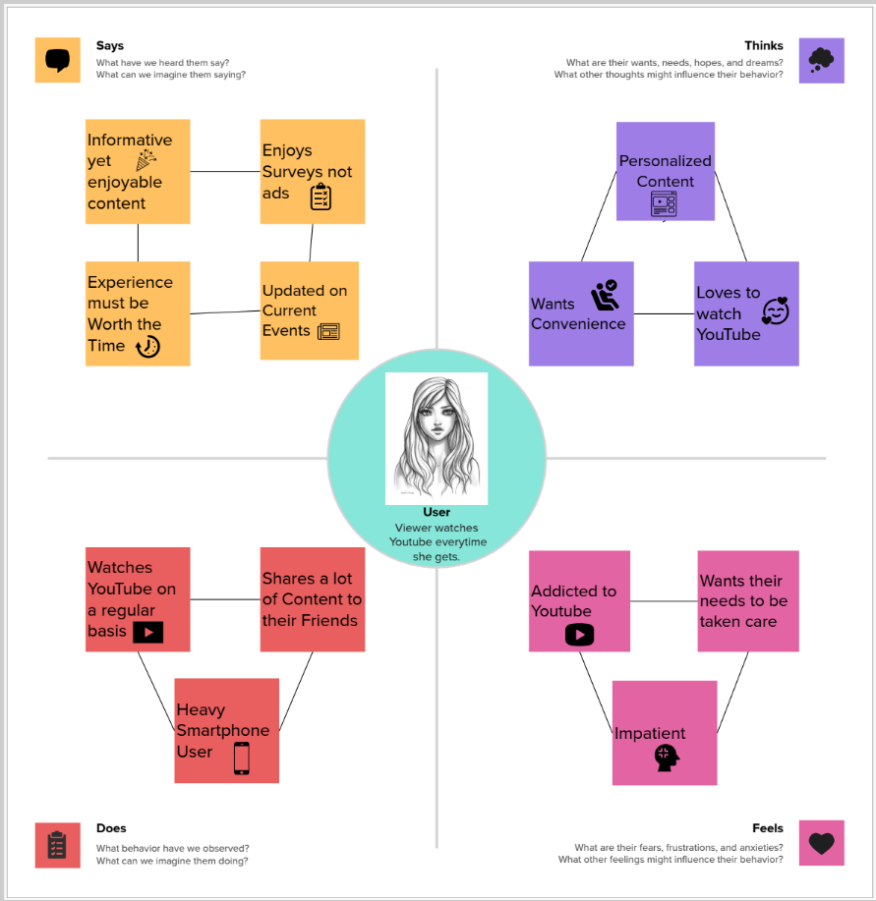

2.2. Brainstorm Map:

3. Result :

4. Advantages & Disadvantages :

5. Applications :

6. Conclusion :

7. Future Scope :

8. Appendix :

